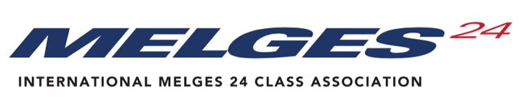
ANNUAL GENERAL MEETING 2022
Saturday, 19 November 2022
According to the IM24CA Constitution, motions, amendments and nominations for the AGM shall be proposed only by the Executive Committee, NCA’s, the Technical Committee and World Sailing and must reach the International Secretary not less than eight (8) weeks before the officially announced date of the meeting. Only the motions, amendments and nominations on the Agenda and its attachment/s shall be voted upon. The Chairman may, in exceptional circumstances, accept amendments from the floor of the AGM when, in his opinion, this will assist the resolution of issues on which the World Council have had an opportunity to express their views.
Deadline for the submissions for the 2022 AGM is October 1st, 2022. To allow this process to function smoothly, the each Submission should adhere to the following guidelines:
- The Submission shall clearly state the current position along with the proposal for a change (clearly stating the rule) and the rationale behind this change.
- The Submission should be written to relate to any IM24CA documents or topics as listed below.
- Wherever possible, each submission should contain wording for the proposed new rules.
- Reason for the motion
- Technical items the tech staff can work on during the year should not be sent as an Submission
Nominating Body
Exec Comm, NCA, Tech Comm

Name and Surname
Position in Nominating
Body

E-mail
Title of the motion,
amendment, nomination

Topics concerned
 | Constitution |  | Events
 | Class Rules |  | Technical issues
 | Regatta Regulations |  | General policies
 | Nomination
Proposal
You can widen
this box if
needed

Reason

